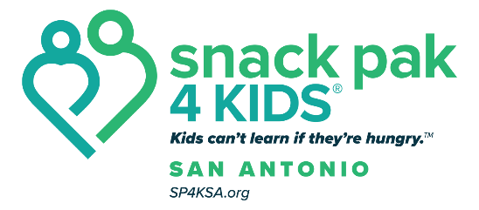

Snack Pak 4 Kids San Antonio—Referral Form (2025-26)

Child’s Name: _______________

Age: Grade: Teacher: _______________________ Classroom #:

Behavior that demonstrated Food Insecurity (Referral MUST include at least one item in this category)
□ Rushing food lines
□ Extreme hunger on Monday morning
□ Eating all of the food served
□ Lingering around for or asking for seconds
□ Comments about not having enough food at home
□ Other

Check any other factors that apply to this child:

Physical Appearance
□ Extreme thinness
- Puffy, swollen skin
- Chronically dry cracked lips
- Chronically dry itchy eyes
- Brittle, spoon-shaped nails
- Other

School Performance
- Excessive absences and/or tardiness
- Repetition of a grade
- Chronic sickness
- Short attention span/inability to concentrate
- Chronic behavior that leads to disciplinary action (hyperactive, aggressive) irritable, anxious, withdrawn, distressed, passive/aggressive)
- Other

Home Environment
□ Often cooks own meal, or have another sibling who does
- Moves frequently
- Often spends the night away from home (primary residence)
- Loss of income
- Family crisis
- Other

If this child needs to receive extra food, please explain why:
Name/title of person referring the student: Date of referral: Date approved: Approved by:

